Dayforce Manager Training: www.dayforcehcm.com
Login with your normal user name & password.
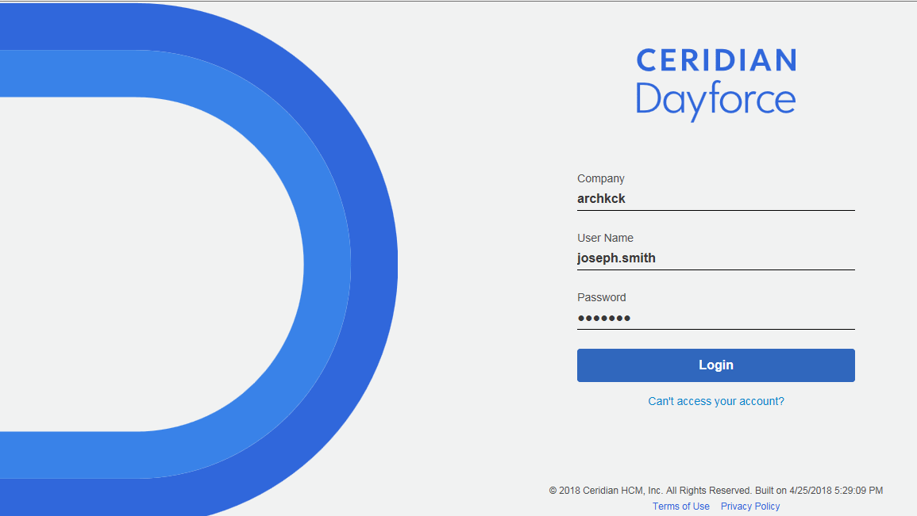

Select your Manager Role when you log in
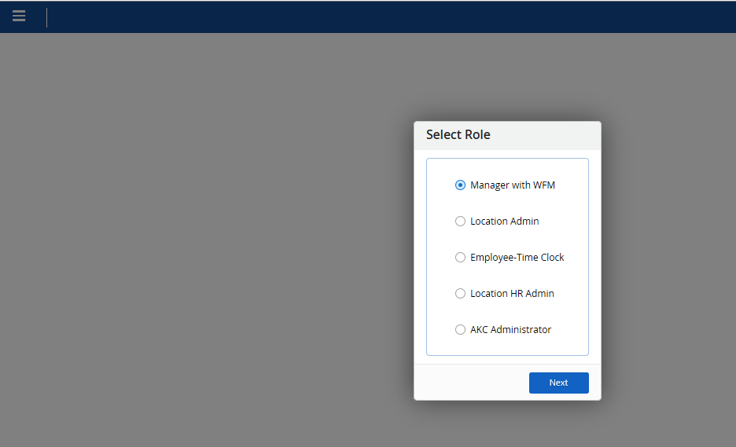
- You may want to edit your Blue Favorites bar on your HOME screen. Click edit on the lower right of the blue bar to move icons to where you want them to appear; drag & drop using the left button on your mouse & SAVE. You should also see your direct report employees on the home screen.
  - “Timesheets” - approving hourly employees time
  - “MyDay” -approving Time off requests for all employees who report to you
  - “MyHR” – Individual employee data; emergency contacts, pay data, etc.
  - “Schedules” – (Optional) - Preset schedules for hourly employees – this set up will payout holidays automatically to hourly employees.
  - “Profiles & Settings” – Your own profile. See tab “Preferences” - Delegation Access
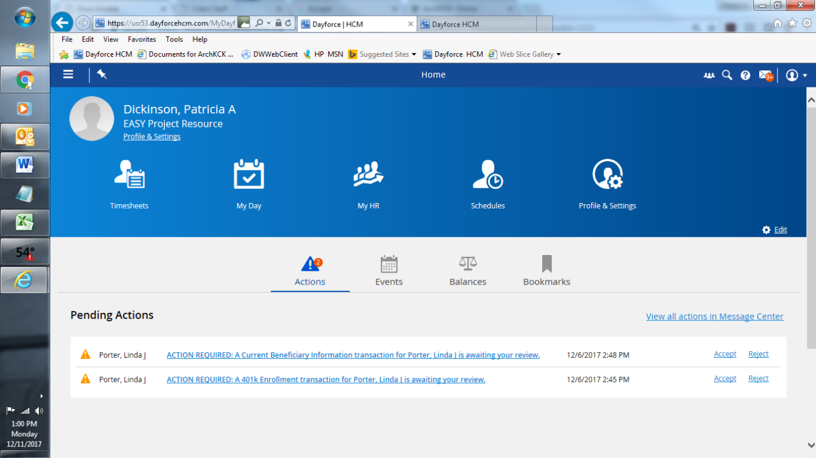
Timesheets: 1 of 4 – Edit & authorize time worked for non-exempt employees.
Click Filter & Sort (see Add Filter-middle of screen) to search by name or narrow your view of employees
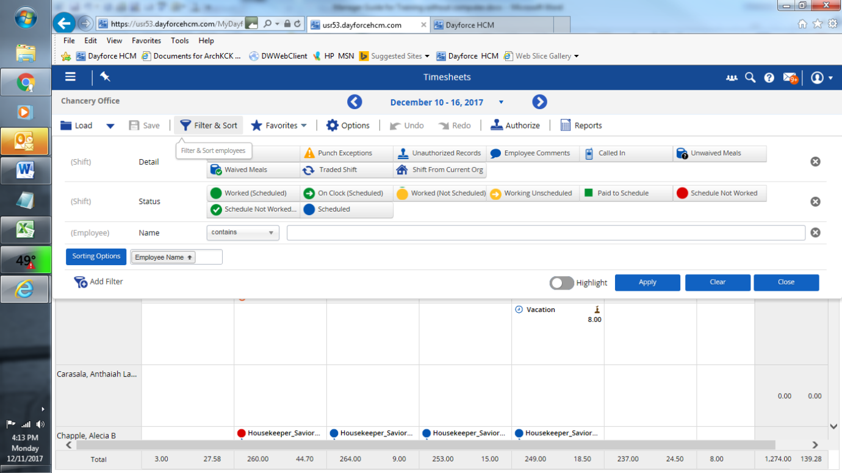
Timesheets 2 of 4 – To Edit Time Worked – Move to the day and Left click mouse. Then click calendar to add a shift or punch. Click the pencil to Edit punches (see screen below) or Click the X to delete the shift.

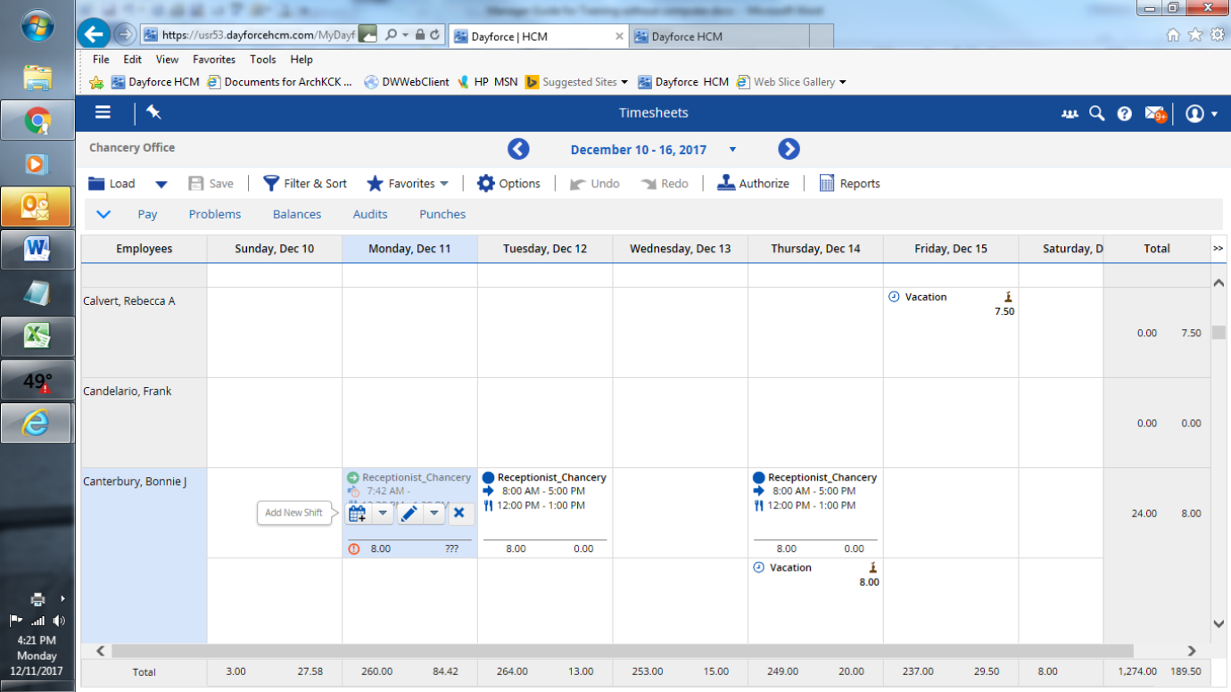

Timesheets 3 of 4–To Edit- click pencil & change data, click any green check marks to accept, then “OK”
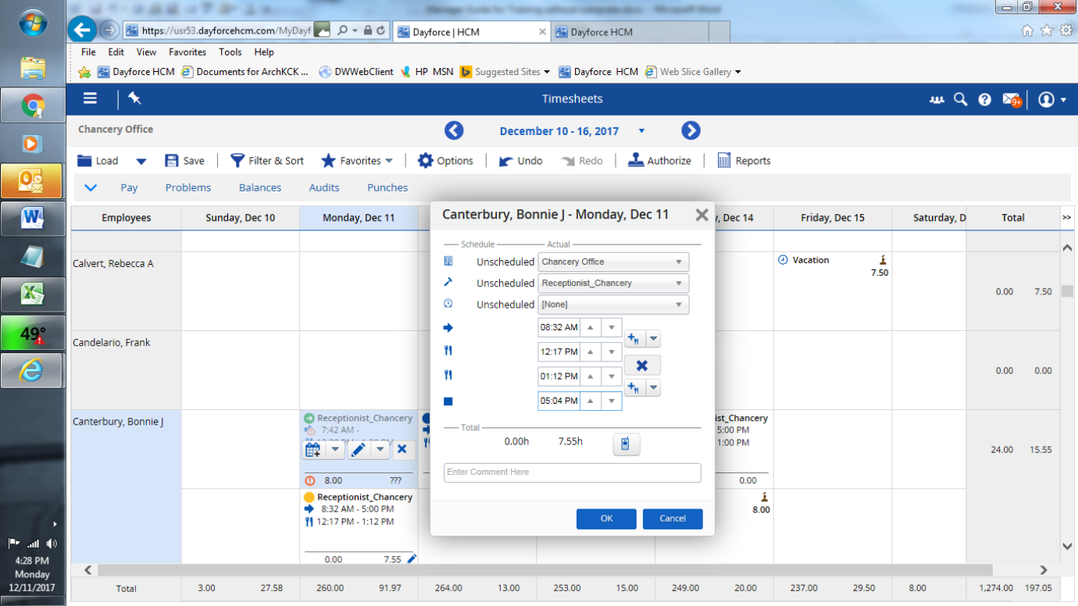
Timesheets 4 of 4 – To Authorize Time – Be sure to check hours worked for missed or incorrect punches. Click on the day and click the “Authorize” stamp above. Notice the stamp appears in the upper right of the square when the day is authorized. You cannot un-authorize, but you can delete and re-enter time.
Click on the Day & Date at the top of the column to authorize everyone for that day or click the employee name to authorize a full week.
IMPORTANT - Click SAVE >> Best practice to authorize daily. <<
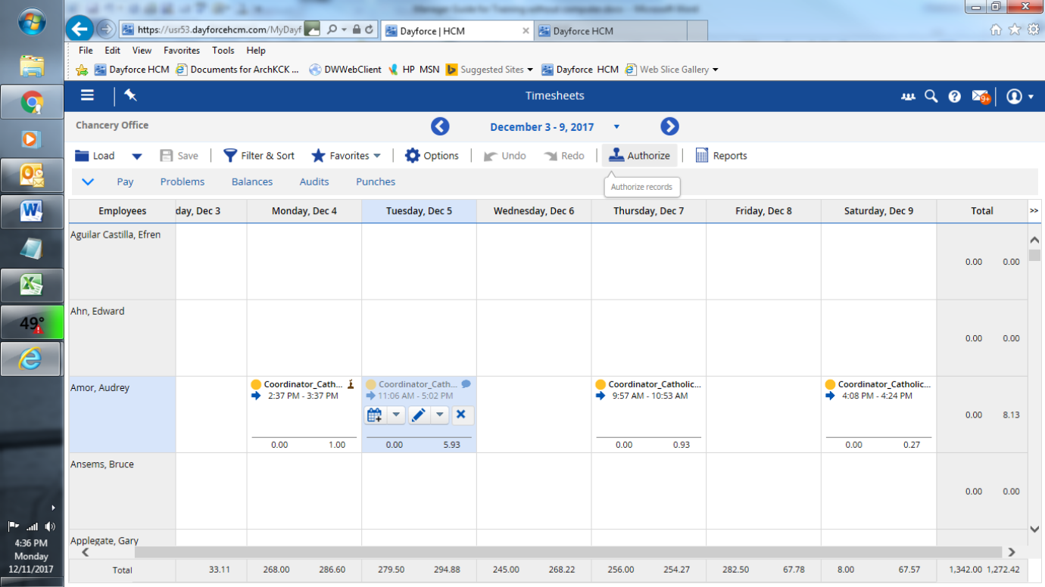
MyDay – 1 of 2 Authorize Time Off Requests – Click on MyDay, find “Time Off Request Manager” (upper left) and click on small dark square in the upper right of the quadrant to expand the view.
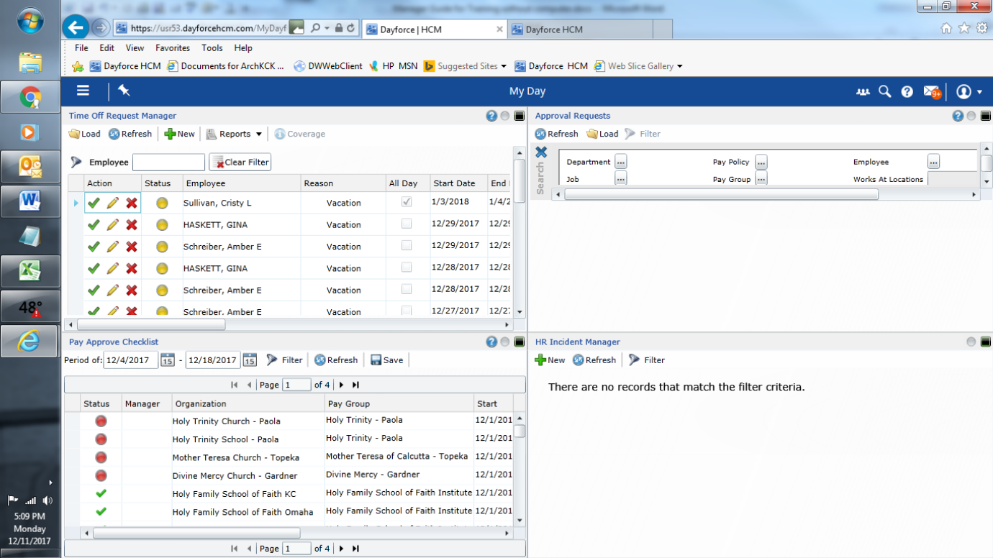
MyDay – 2 of 2 Authorize Time Off Requests
Click Green Check to approve, Pencil to edit or view and Red X to Deny. Caution on Manager comments which can be viewed by the employee.
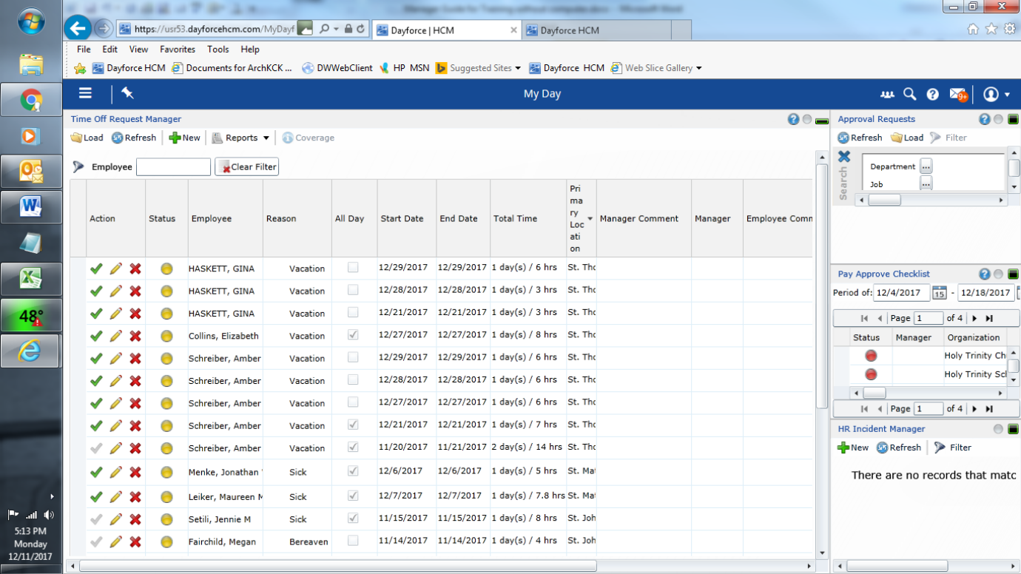

Click MyHR to view employment details on individual employees. Click Filter, at top, to select Employee.
Notice left column - multiple Categories of Data and Multiple Tabs; click “Details” “Emergency contact”
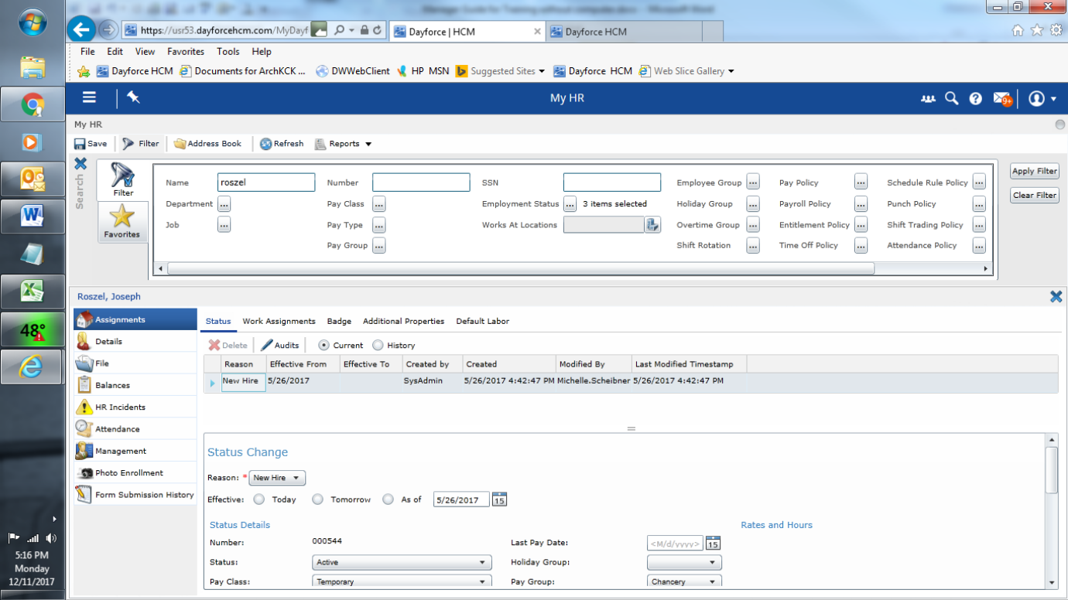
(Optional) Click Schedules – Future scheduled times hourly employees are set to work. A holiday that occurs on one of these scheduled times will automatically payout to the hourly employee.
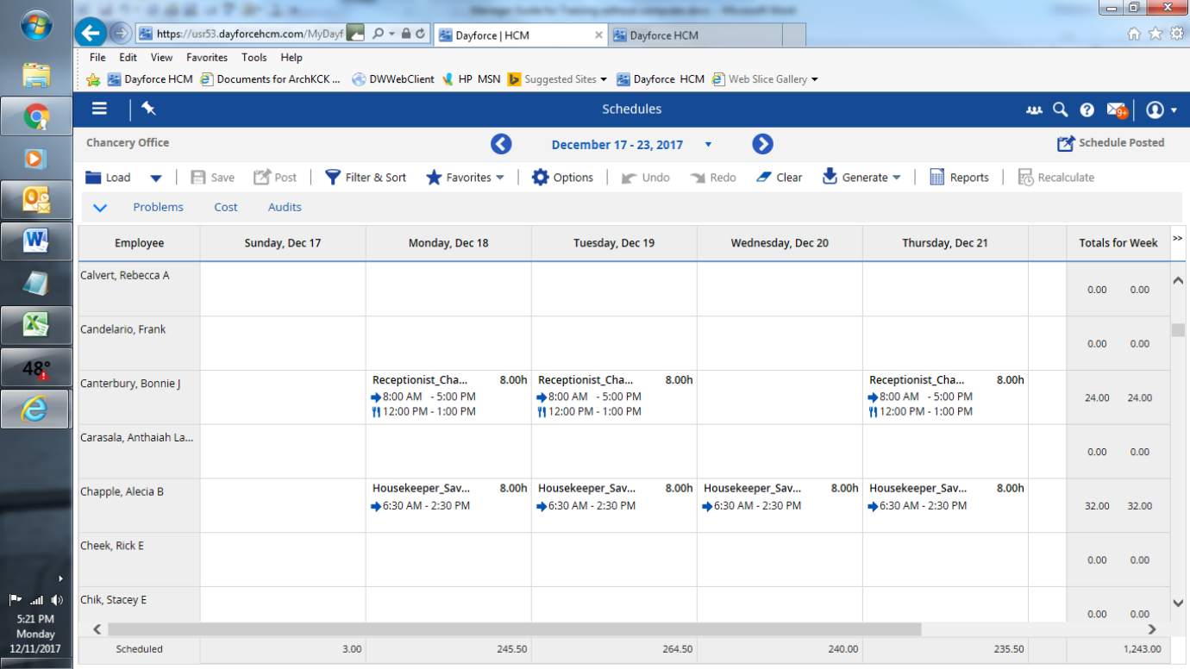

Click Profiles & Settings - click “Preferences” tab, notice “Delegation Access” – Assigns a Delegate to authorize time and time off requests in the manager’s absence.
IMPORTANT: Be sure to check the “Restrict Private Information” Boxes to block the delegate’s view of employee private data. Plan B is management authorizations via the Mobile Phone App while away.
